[Level1] 1
[Level 2] 2
[Level 3] 3
[Level 4] 4
[Level 5] 5

[Level1]
We started by selecting a background image to use in the project. We created a Canvas with an 'Event System' and added a child Image anchored to the center of the screen, configuring it to use the background image sprite. We adjusted the resolution to Full HD and renamed the Canvas to 'Background'. We imported the TextMeshPro package, which allowed us to create texts, including the title. We then created a second Canvas called 'QuizCanvas' with a text element and buttons organized in a vertical group. We also created a prefab for the buttons (Fig.1).

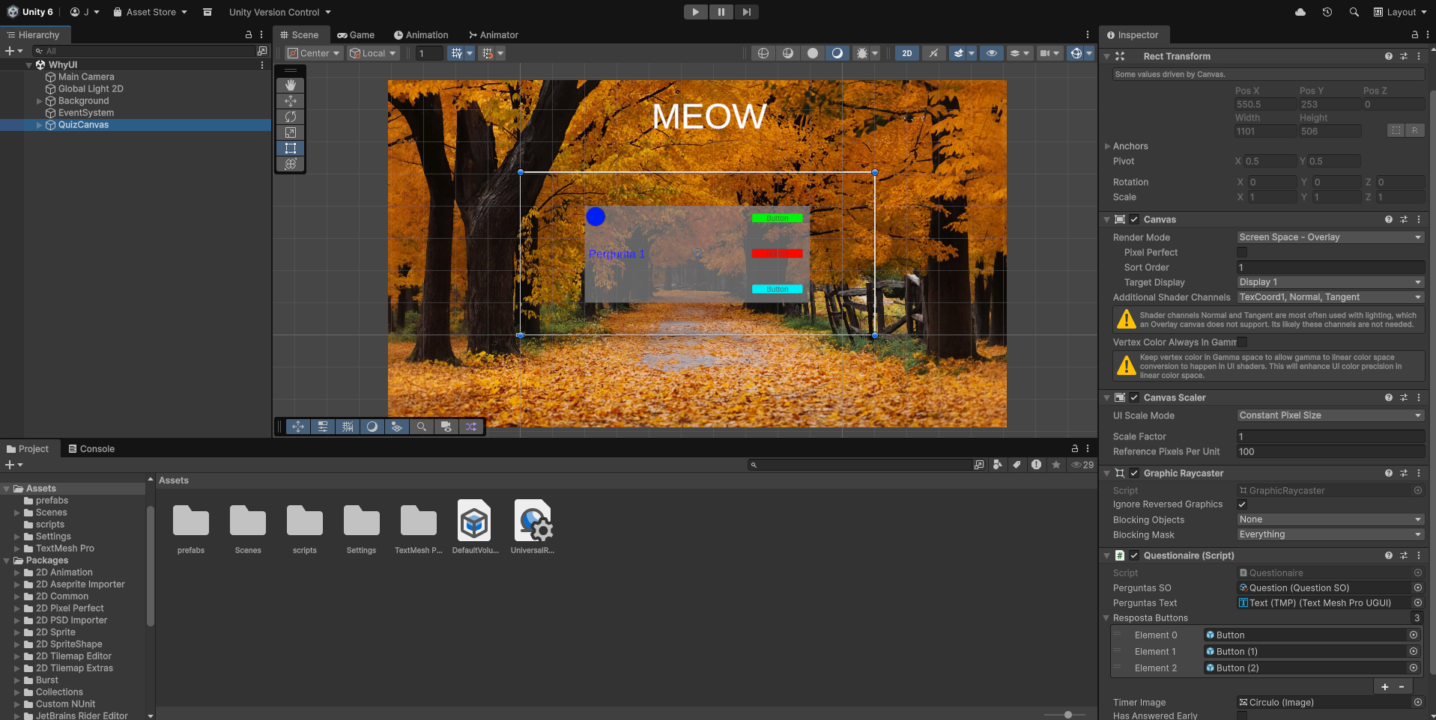
Fig.1

[Level 2]
We replaced the buttons in 'QuizCanvas' with instances. We created a folder for scripts and a ScriptableObject called 'QuestionSO' (Fig.2) with the necessary parameters, including a variable 'question' with the TextArea attribute, a private array of four strings for the answers, and a variable to store the index of the correct answer, all visible in the Inspector (Fig.3).

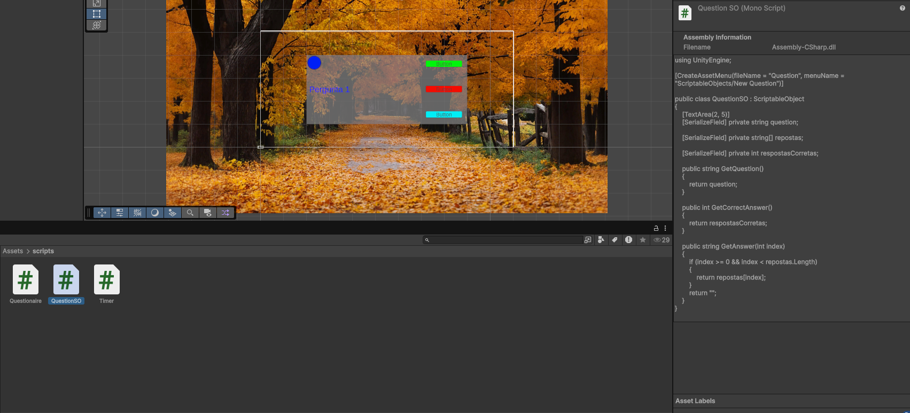
Fig.2

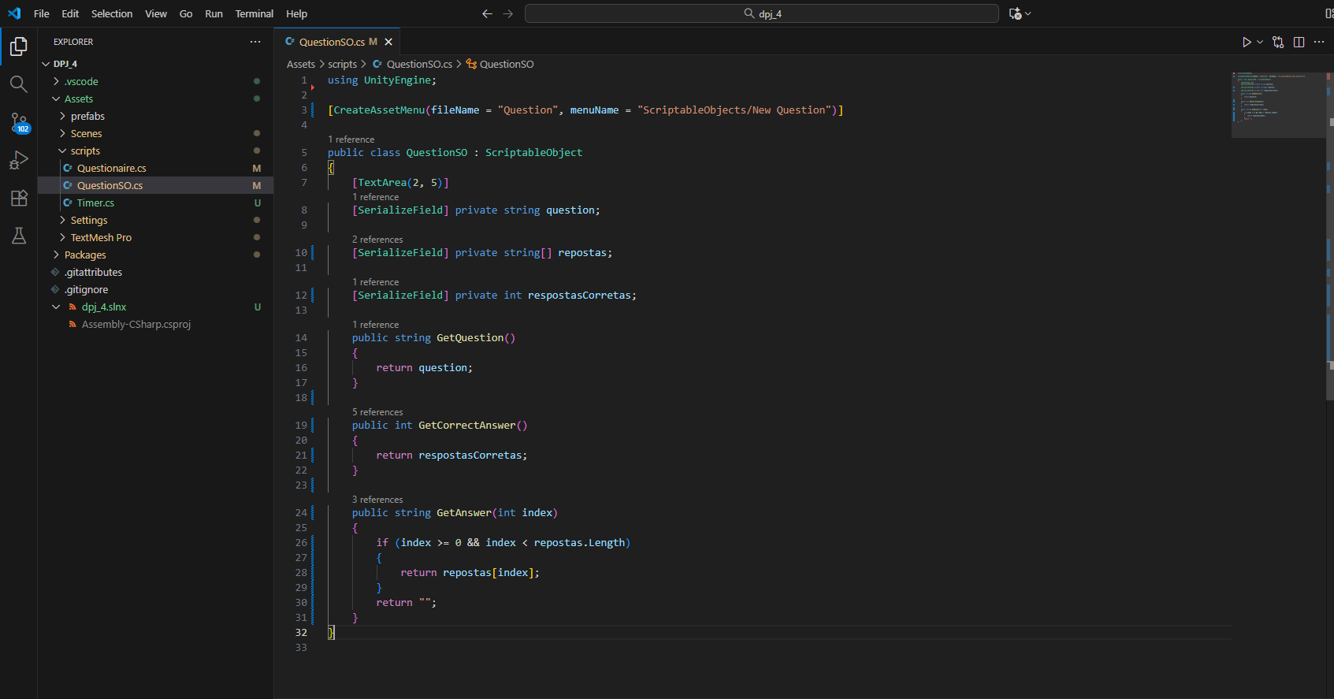
Fig.3

[Level 3]
We created the ScriptableObject for questions with public methods to retrieve the question, the correct answer index, and the individual answers. We assigned the values in the Inspector for the created ScriptableObjects. We then created the 'Questionaire' script (Fig.4), attached it to the 'QuizCanvas', and defined variables for the QuestionSO, text, and correct answer index, displaying the question right at Start().

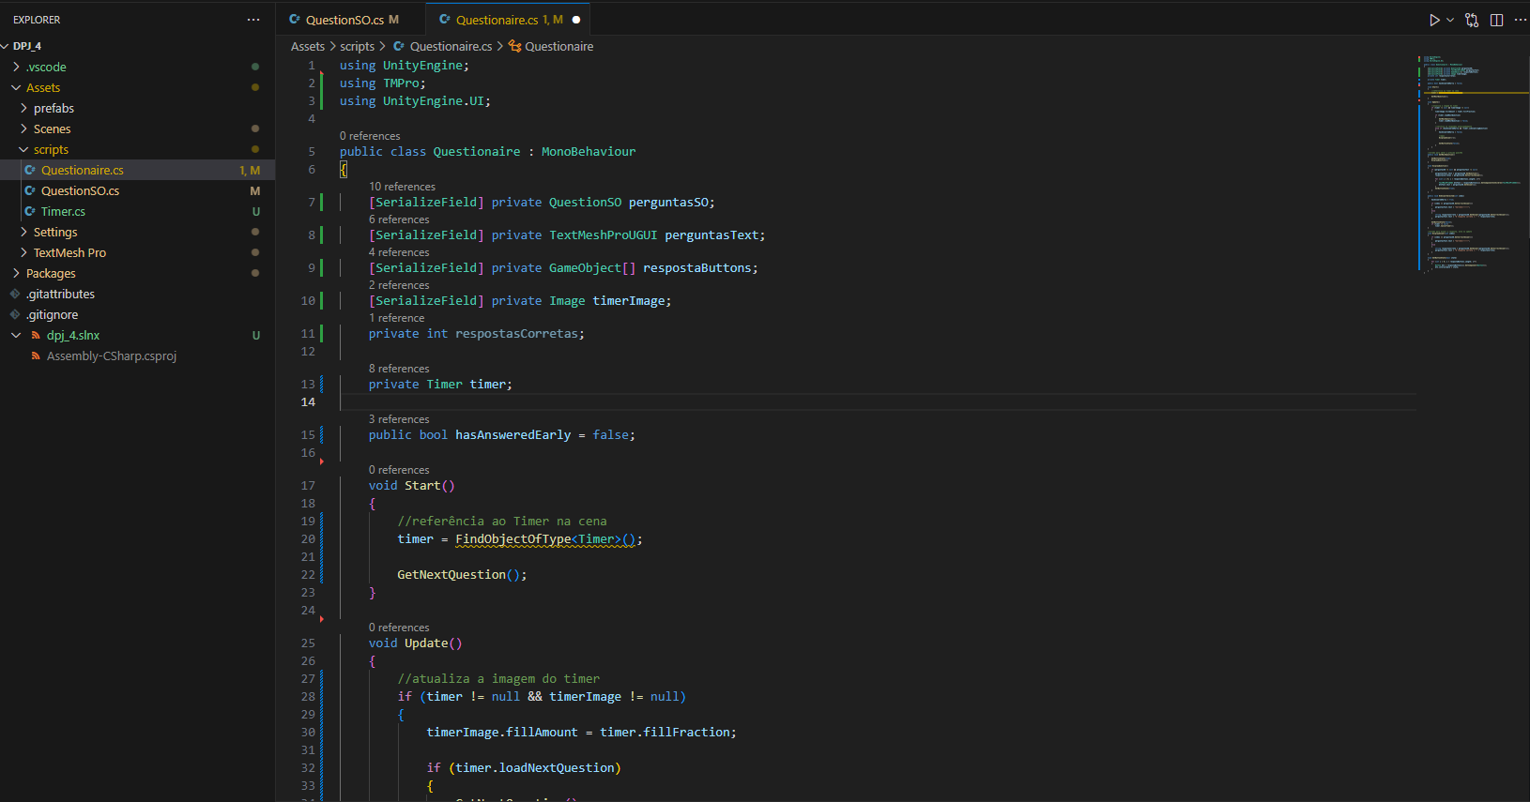
Fig.4

[Level 4]
In the 'Questionaire' script, we added a private array to store the answer buttons, linked in the Inspector. In Start(), we created a loop to assign the answer texts to the buttons. We created the 'OnAnswerSelected' method (Fig.5), which compares the chosen answer with the correct one, changing the question text to 'Correct' or showing the right answer if the selected one is wrong. We configured the buttons' OnClick events to call this method with the appropriate index. We also created methods to display the question ('DisplayQuestion') and to control the buttons' interactivity ('SetButtonState'), disabling them after a selection is made (Fig.6).

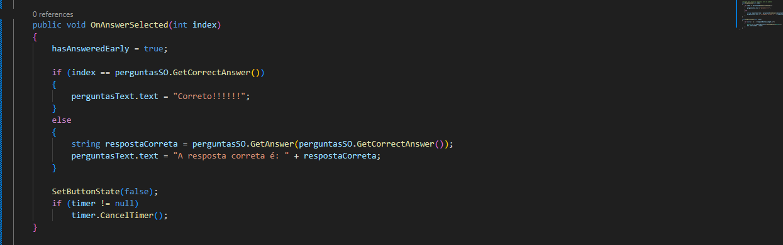
Fig.5

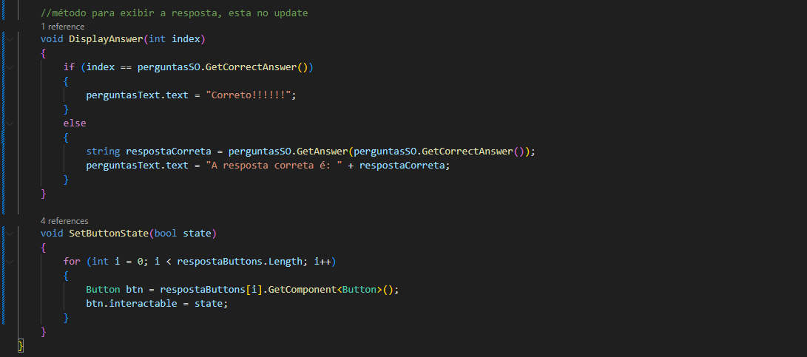
Fig.6

[Level 5]
We added the 'GetNextQuestion' method in the 'Questionaire' script, which activates the buttons and displays the question. In Start(), we called this method. We created a circular 'Image' GameObject as a visual timer in the Canvas (Fig.7), configured with Image Type set to 'Filled' and 'Fill Origin' set to 'Top', to show the time progress. We added a child GameObject 'Timer' with a 'Timer' script that manages the time to answer and display the result, with public variables visible in the Inspector. The UpdateTimer() method controls the countdown, state changes, and calculation of the fill fraction. We linked the visual timer to the 'Questionaire', updating the fillAmount according to time progress. We created the CancelTimer() method to reset the timer when an answer is given. We also added variables to track whether the answer was given early and whether the next question should load automatically.

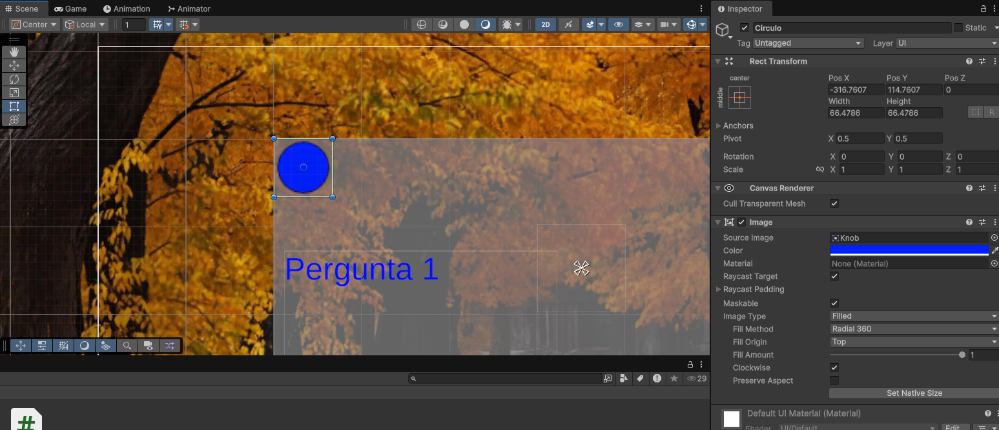
Fig.7

